Bug Report

Log In Screen

Title: Page not available when entering wrong user
Description: In the log in screen when you enter a wrong user and the password field is not empty the app fails with “Page not available”.
Environment: https://wmxrwq14uc.execute-api.us-east-1.amazonaws.com/Prod/Account/Login
Steps to reproduce: In the log in screen…
1. In the Username field enter a not valid user like WrongUser
2. In the Password field enter anything like WrongPassword
3. Click on Log In button
Expected result: The app should indicate that the User or Password is incorrect.
Actual result: The app shows “Page is not available”

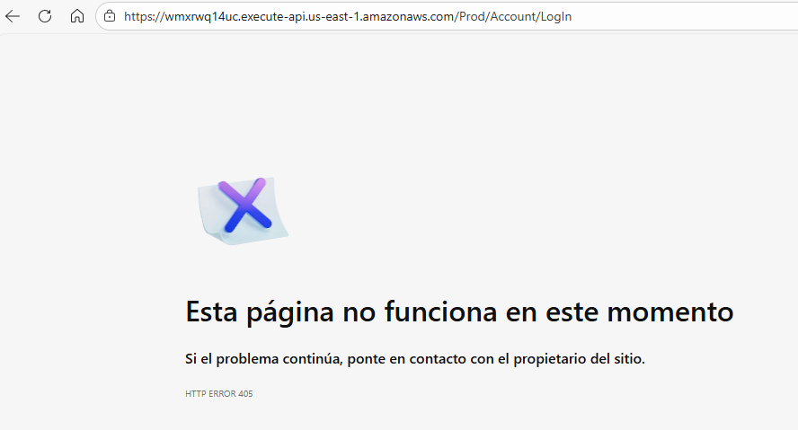
Title: Paylocity Benefits Dasboard link display empty table
Description: In the log in screen when you click on the Paylocity Benefits Dasboard link, it shows an empty table.
Environment: https://wmxrwq14uc.execute-api.us-east-1.amazonaws.com/Prod/Account/Login
Steps to reproduce: In the log in screen…
1. Click on the Paylocity Benefits Dasboard link
Expected result: The app should not display any table. It should remain in the log in screen until the user is authenticated successfully.
Actual result: The app display the dashboard with an empty table.

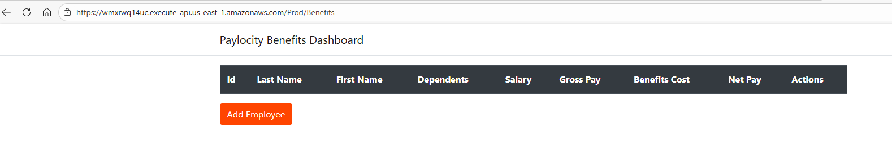

Add Employee Screen

Title: When adding an employee the first and last names are switched.
Description: When adding a new employee the first and last names are swithed in the dashboard table.
Environment: https://wmxrwq14uc.execute-api.us-east-1.amazonaws.com/Prod/Account/Login
Steps to reproduce: once you are logged into the Benefits Dashboard…
1. Click on the Add Employee button
2. Enter any First Name
3. Enter any Last Name
4. Enter any Dependants number
5. Click on Add button.
Expected result: The first and last name should be added in the proper column in the dashboard table.
Actual result: The first and last names are switched and displayed incorrectly in the dashboard table.

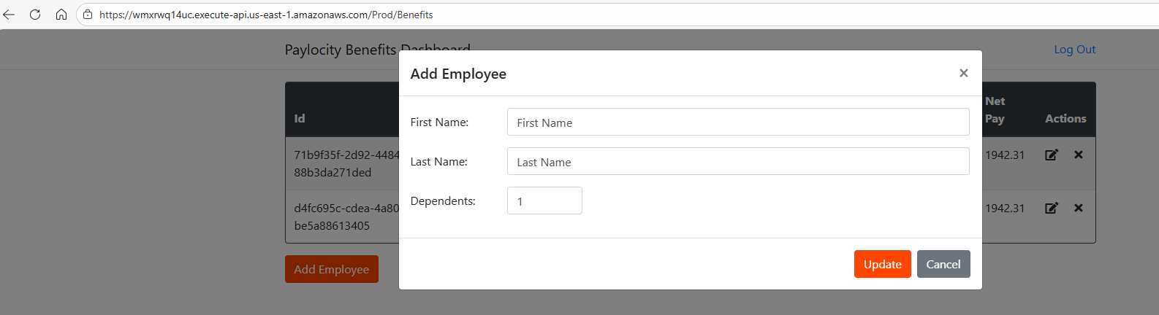
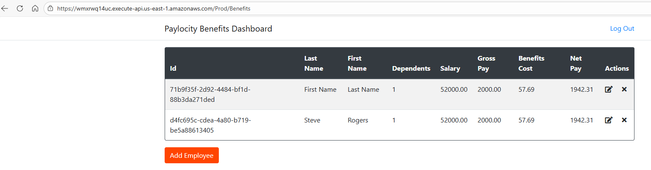

Title: The app does not show any help with empty fields or wrong field type entered.
Description: When trying to add an employee with empty fields or wrong type the app does not show any help to see what is wrong and why it does not allow to add the employee.
Environment: https://wmxrwq14uc.execute-api.us-east-1.amazonaws.com/Prod/Account/Login
Steps to reproduce: once you are logged into the Benefits Dashboard…
1. Click on the Add Employee button
2. Try any of the following, in all cases will happen the same issue:
- Do not enter anything in any field.
- Leave just one field empy
- Enter correct first and last name but enter a string in the Dependent field
- Enter first and/or last name with more than 50 characters and correct dependent number.
- Enter correct first and last names but enter 33 or more dependents.
3. Click on Add button.
Expected result: The app should display which field is wrong or what is the right format expected and/or its limitations, so the user can know why cannot add an employee with the information entered.
Actual result: The app does not display any help

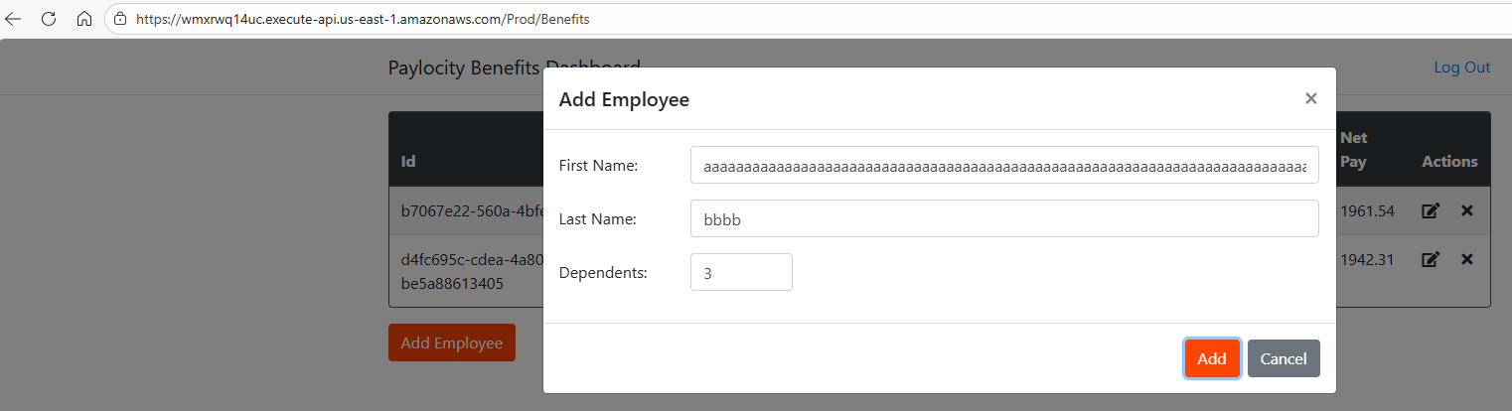
Title: The application allows to add same employee even it creates different/unique Id for it
Description: We can add more than one employee with same first and last name but that could be confusing. Would be better if can add a field like short employee number to easy differenciate it and diaplay a message with the employee id created so we can identify it and use it in other tests, otherwise it hard to edit or delete the proper employee looking for its first and last names.
Environment: https://wmxrwq14uc.execute-api.us-east-1.amazonaws.com/Prod/Account/Login
Steps to reproduce: once you are logged into the Benefits Dashboard…
1. Click on the Add Employee button
2. Enter existing employee information like:
- First Name: aa
- Last Name: aa
- Dependents: 0
3. Click on Add button.
Expected result:. Would be much better to have shorter employee number to make reference of it to avoid confusion or display the employee id generated to look for it later on.
Actual result: The app allows to add an existing employee (same first and last name) even if it creates a different ID.

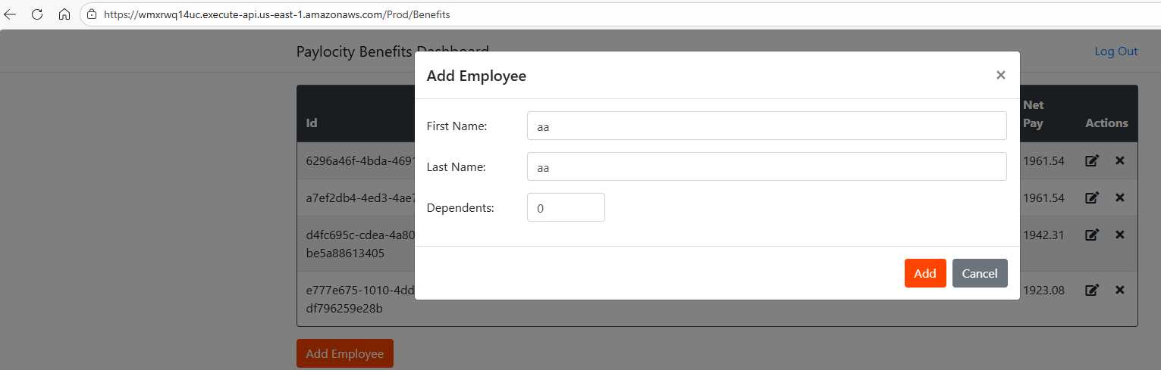
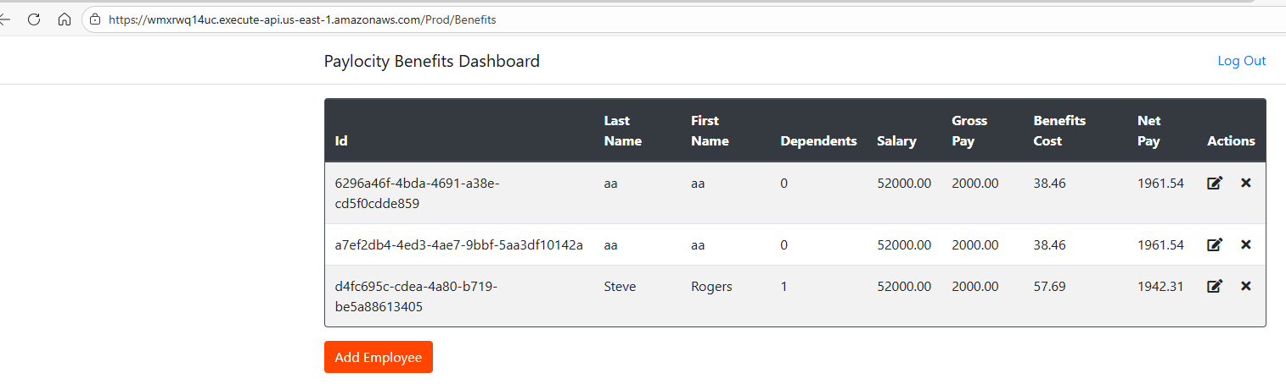
Title: The app allows to enter only symbols to the employee name (first and last)
Description: We can add an employee with only symbols in their first and/or last names.
Environment: https://wmxrwq14uc.execute-api.us-east-1.amazonaws.com/Prod/Account/Login
Steps to reproduce: once you are logged into the Benefits Dashboard…
1. Click on the Add Employee button
2. Enter an employee with symbols:
- First Name: ###
- Last Name: %%
- Dependents: 0
3. Click on Add button.
Expected result: It should not allow to add an employee with only symbols, should display help for the right format to use in those fields.
Actual result: The app allows to add an employee with only symbols in the first and last names.

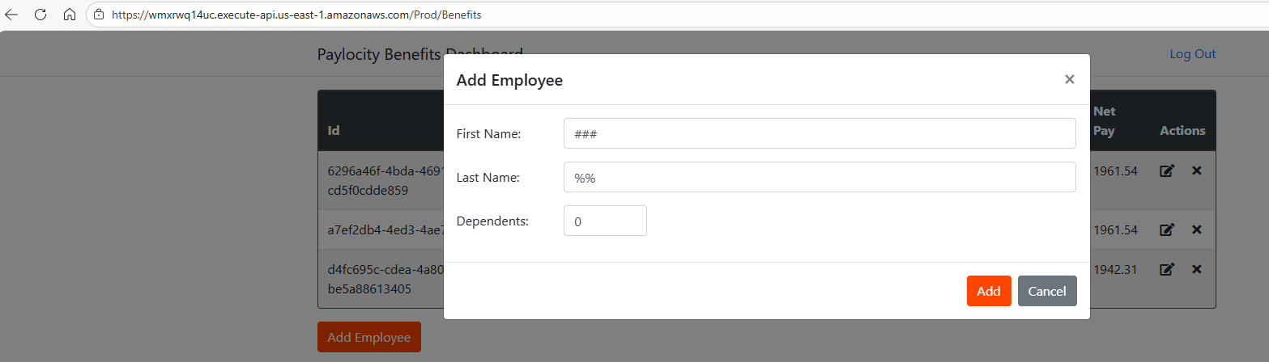
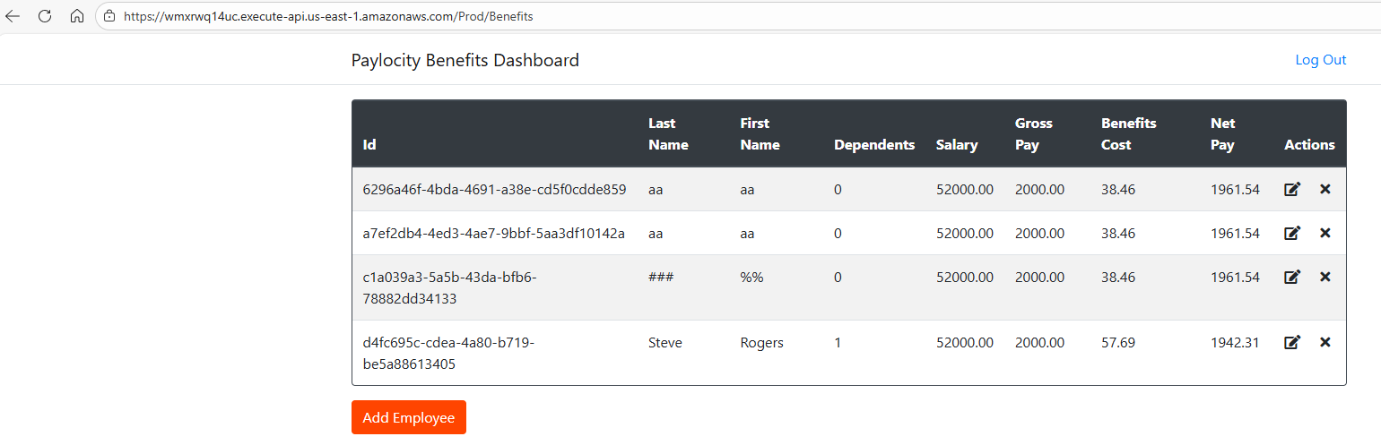
Edit Employee Screen

Title: Window title is wrong when editing an employee
Description: When eiditing an employee information the window title is still displaying Add Employy instead of Update or Edit Employee.
Environment: https://wmxrwq14uc.execute-api.us-east-1.amazonaws.com/Prod/Account/Login
Steps to reproduce: once you are logged into the Benefits Dashboard…
1. Click on the Edit action for any employee
Expected result: The window title should display Update or Edit Employee.
Actual result: The window title shows Add Employee label.

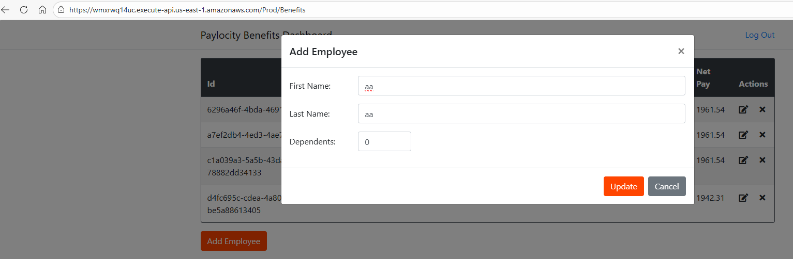
Paylocity Benefits Dashboard Screen

Title: The table layout breaks when names (First and/or Last) are too long
Description: When adding a new employee with long names like 50 characters the table layout breaks.
Environment: https://wmxrwq14uc.execute-api.us-east-1.amazonaws.com/Prod/Account/Login
Steps to reproduce: once you are logged into the Benefits Dashboard…
1. Click on the Add Employee button
2. Enter an employee with long names:
- First Name: aaaaaaaaaaaaaaaaaaaaaaaaaaaaaaaaaaaaaaaaaaaaaaaaaa
- Last Name: aaaaaaaaaaaaaaaaaaaaaaaaaaaaaaaaaaaaaaaaaaaaaaaaaa
- Dependents: 5
3. Click on Add button.
Expected result: The employee is added but the table layout should adjust properly.
Actual result: The employee is added but the table layout breaks.

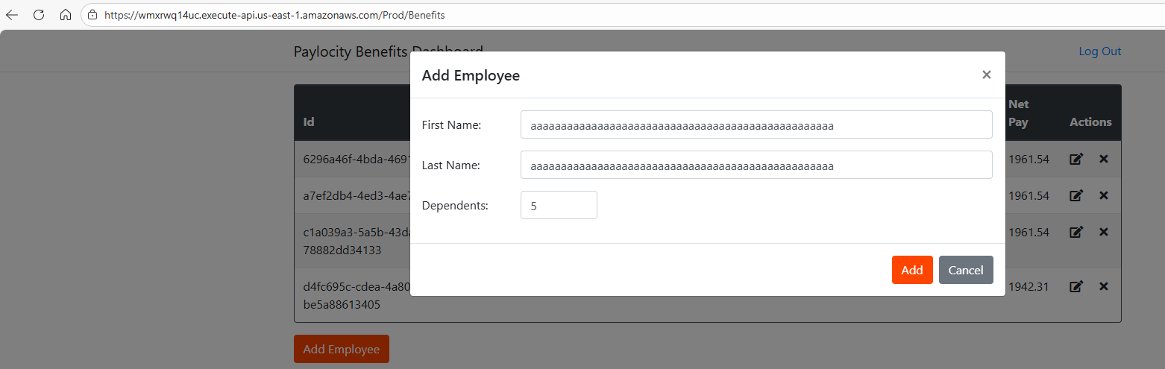
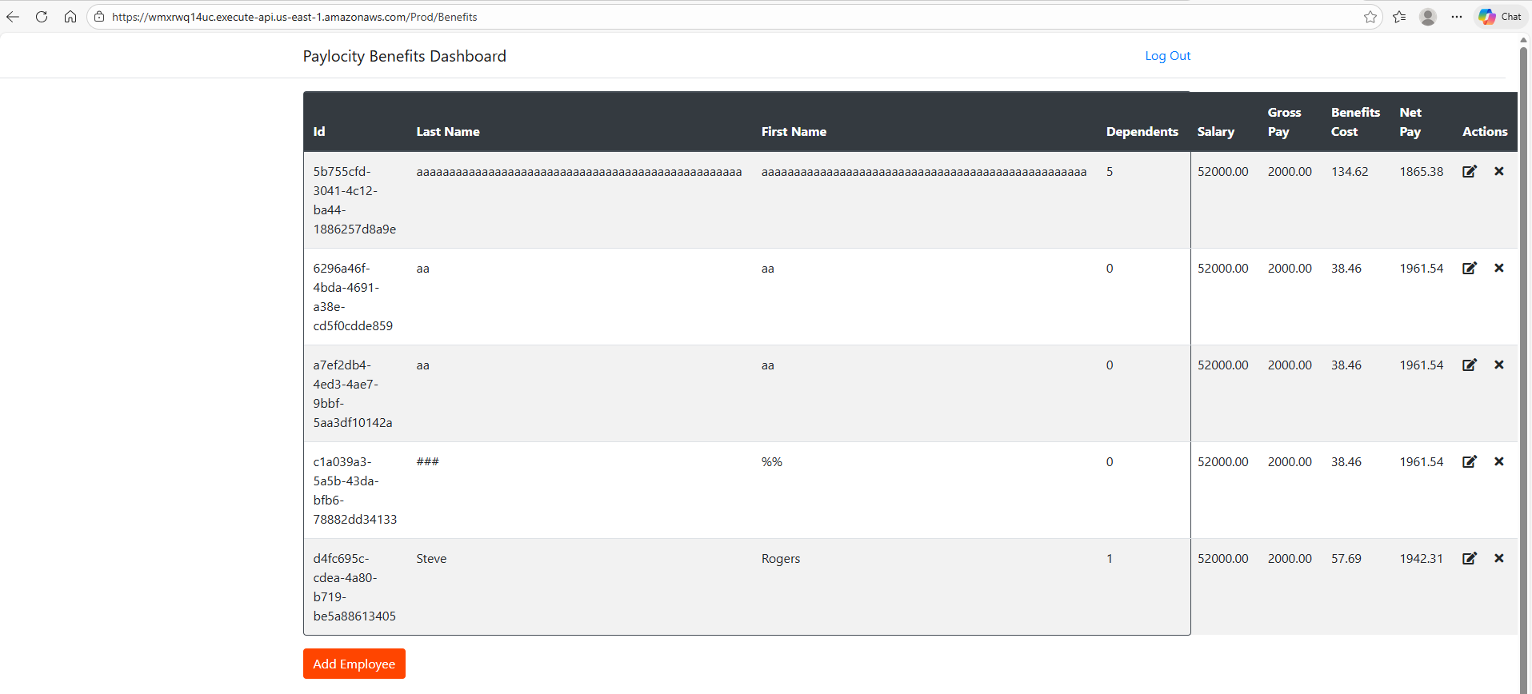
Title: The application does not show any message for any action perform.
Description: Any action we perform in the application like add a new employee, edit employee or delete employee the app does not show any confirmation message hence is not obvious to see quickly if the action was done or not.
Environment: https://wmxrwq14uc.execute-api.us-east-1.amazonaws.com/Prod/Account/Login
Steps to reproduce: once you are logged into the Benefits Dashboard try any action below.
1. Add new employee
2. Edit employee
3. Delete employee.
Expected result:. Any action perform should display a confirmation message.
Actual result: The app does not show any confirmation message for any action taken.

